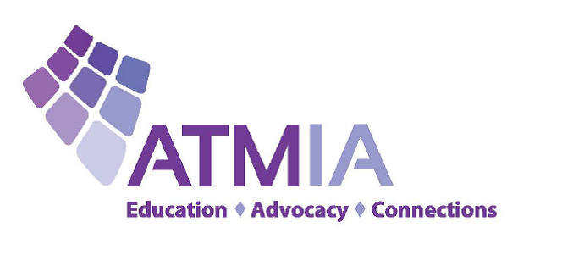

For immediate media release
Countdown to the Grand Launch of Next Generation ATM Architecture
LONDON, UNITED KINGDOM, SIOUX FALLS, SD, USA, March 8, 2018 - ATMIA today announced that next generation ATM architecture will be launched at the association’s main European event “ATM & Payments Innovation Summit” which takes place on 17th-19th October, 2018 at the Eurostars Madrid Tower Hotel.
“The Governance and PR & Communications subcommittees of the Consortium for Next Generation ATMs, which has grown to 125 companies across the world, determined that we should aim for a public launch of this new ATM ecosystem for the world at our upcoming European conference in Madrid,” Mike Lee, CEO of ATMIA, announced. “It’s time to link 3 million ATMs to 5 billion mobile phones. This is the industry’s vision of its future.”
“What better place could there be than an ATMIA event in Madrid to launch Next Generation ATM architecture? Spain has been a leading nation in the field of ATM innovation for many years and the ATMIA is certainly the only worldwide Industry Trade Association with the credibility to guide the project to full fruition,” commented Ron Delnevo, Executive Director Europe of ATMIA.
The Consortium for Next Generation ATMs is a global future-proofing exercise made up of companies in all major markets representing every sector of the ATM value chain.
“The global blueprint signed off by the Consortium represents the biggest consensus every achieved in our industry on the way forward to keep ATMs relevant for tomorrow’s world,” Lee added.
About ATMIA www.atmia.com
ATMIA is the leading non-profit trade association representing the entire global ATM industry. ATMIA serves more than 10,700 members from over 650 participating companies in 67 countries spanning the whole ATM ecosphere, including financial institutions, independent ATM deployers, equipment manufacturers, processors and a plethora of ATM service and value-added solution providers. ATMIA provides education, advocacy and connections to help its members keep abreast of industry news and developments; increase knowledge and professionalism; improve operational efficiencies; understand and influence regulatory processes; participate in the local, regional and global ATM community; and forge new relationships to advance their businesses. Founded in 1997, ATMIA has active chapters in the United States, Canada, Europe, Latin America, Asia-Pacific, Asia, Africa, India and the Middle East focusing on the unique needs and issues of each region. For more information, please visit atmia.com. Follow us on LinkedIn, Twitter or YouTube.

